//Assignment tcp in C

/***** A7. A. Arithmatic client *****/

// Client

import java.io.*;

import java.net.*;

public class arithtcpclient

{

public static void main(String[] args) throws IOException

{

System.out.println();

System.out.println("ARITHMETIC CLIENT");

System.out.println("*****************");

try

{

Socket clientsoc = new Socket("localhost", 6666);

System.out.println("Enter the inputs");

PrintWriter out = new PrintWriter(clientsoc.getOutputStream(), true);

BufferedReader in = new BufferedReader(new InputStreamReader(clientsoc.getInputStream()));

BufferedReader stdin = new BufferedReader(new InputStreamReader(System.in));

String userinput;

while (true)

{

do

{

userinput = stdin.readLine();

out.println(userinput);

}while(!userinput.equals("."));

System.out.println("Sever Says : " + in.readLine());

}

}

catch(Exception e)

{

System.exit(0);

}

}

}

/**** A7. A. Arithmatic Server ****/

//arithtcpserver

import java.io.*;

import java.net.*;

public class arithtcpserver

{

public static void main(String arg[]) throws Exception

{

System.out.println();

System.out.println("ARITHMETIC SERVER");

System.out.println("*****************");

System.out.println("Server is ready to accept inputs…");

ServerSocket serversoc=new ServerSocket(6666);

Socket clientsoc = serversoc.accept();

PrintWriter out = new PrintWriter(clientsoc.getOutputStream(), true);

BufferedReader in = new BufferedReader(new InputStreamReader(clientsoc.getInputStream()));

String inputline;

BufferedReader stdin = new BufferedReader(new InputStreamReader(System.in));

try

{

while (true)

{

String s,op="",st;

int i=0,c=0;

int[] a=new int[2];

while(true)

{

s=in.readLine();

if(s.equals("+") || s.equals("-") || s.equals("*") || s.equals("/"))

op=s;

else if(s.equals("."))

break;

else

{

a[i]=Integer.parseInt(s);

i++;

}

}

if(op.equals("+"))

c=a[0]+a[1];

else if(op.equals("-"))

c=a[0]-a[1];

else if(op.equals("*"))

c=a[0]*a[1];

else if(op.equals("/"))

c=a[0]/a[1];

s=Integer.toString(c);

out.println(s);

}

}

catch(Exception e)

{

System.exit(0);

}

}

}

*****OUTPUT*****

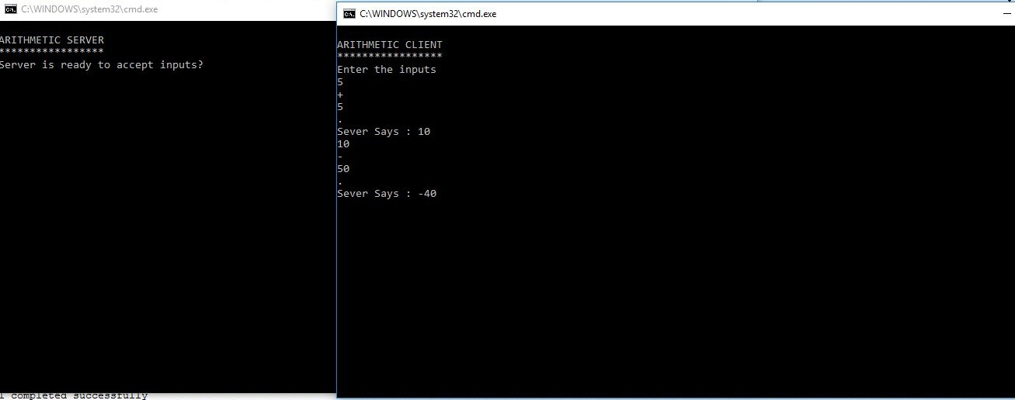

/*** A7.B. File transfer client ***/

#include<sys/types.h>

#include<sys/socket.h>

#include<stdio.h>

#include<netinet/in.h>

#include <unistd.h>

#include<string.h>

#include<strings.h>

#include <arpa/inet.h>

#include <stdlib.h>

#define MAXBUFLEN 1000000

//#define buffsize 150

void main()

{

int b,sockfd,sin_size,con,n,len;

//char buff[256];

if((sockfd=socket(AF_INET,SOCK_STREAM,0))>=0)

printf("Socket Created Sucessfully \n");

struct sockaddr_in servaddr;

servaddr.sin_family=AF_INET;

servaddr.sin_addr.s_addr=inet_addr("127.0.0.1");

servaddr.sin_port=6007;

sin_size = sizeof(struct sockaddr_in);

if((connect(sockfd,(struct sockaddr *) &servaddr, sin_size))==0) //initiate a connection on a socket

printf("Connect Sucessful \n");

char buffer[10000];

char c[10000];

FILE *fp;

//bzero(buffer,10000);

//bzero(c,10000);

read(sockfd, buffer, 10000);

fp= fopen("/home/Student/1/CNL/Group A/Assg2_TCPSocket/Assg2_b/receive.txt", "w+");

/* Read and display data */

fwrite(buffer, 1,strlen(buffer) + 1, fp);

//fseek(fp, 0, SEEK_SET);

//fread(c, strlen(buffer)+1, 1, fp);

printf("Received File Contents :%s \n", buffer);

fclose(fp);

close(sockfd);

}

/*** A7.B. File transfer server ***/

#include<sys/types.h>

#include<sys/socket.h>

#include<stdio.h>

#include<netinet/in.h>

#include <unistd.h>

#include<string.h>

#include <arpa/inet.h>

#include <stdlib.h>

#define MAXBUFLEN 1000000

void main()

{

int b,sockfd,connfd,sin_size,l,n,len;

if((sockfd=socket(AF_INET,SOCK_STREAM,0))>=0) //socket creation

printf("Socket Created Sucessfully \n"); //on success 0 otherwise -1

struct sockaddr_in servaddr;

struct sockaddr_in clientaddr;

servaddr.sin_family=AF_INET;

servaddr.sin_addr.s_addr=inet_addr("127.0.0.1");

servaddr.sin_port=6007;

if((bind(sockfd, (struct sockaddr *)&servaddr,sizeof(servaddr)))==0) //bind() assigns the

// address specified by addr to the socket referred to by the file

// descriptor sockfd. addrlen specifies the size, in bytes, of the

// address structure pointed to by addr. Traditionally, this operation is

// called â€œassigning a name to a socketâ€.

printf("Bind Sucessful \n");

if((listen(sockfd,5))==0) //listen for connections on a socket

printf("Listen Sucessful \n");

sin_size = sizeof(struct sockaddr_in);

if((connfd=accept(sockfd,(struct sockaddr *)&clientaddr,&sin_size))>0)

printf("Accept Sucessful \n");

char buffer[100];

char c[10000] = "this is file transfer program";

//char source[MAXBUFLEN + 1];

//bzero(buffer,10000);

FILE *fp;

fp= fopen("/home/Student/1/CNL/Group A/Assg2_TCPSocket/Assg2_b/send.txt", "w+");

//fp = fopen("file.txt", "w+");

/* Write data to the file */

fwrite(c, 1, strlen(c) + 1, fp);

/* Seek to the beginning of the file */

fseek(fp, 0, SEEK_SET);

/* Read and display data */

fread(buffer, 1,strlen(c)+1, fp);

// fclose(fp);

write(connfd, buffer, strlen(buffer));

printf("Sent File Contents: %s\n", buffer);

fclose(fp);

close(sockfd);

}

***OUTPUT***

